
QUALITY ALERT

Customer: United Date: Jan 26, 2025
Die: 15141 Colour: All
Type of Complaint: Customer REJECTED

Q.A # 26-005 NCR: 048 RMA#: 472

Description: Customer REJECTED due to oversized wool pile pocket, causing the wool pile to come loose and not stay in place.

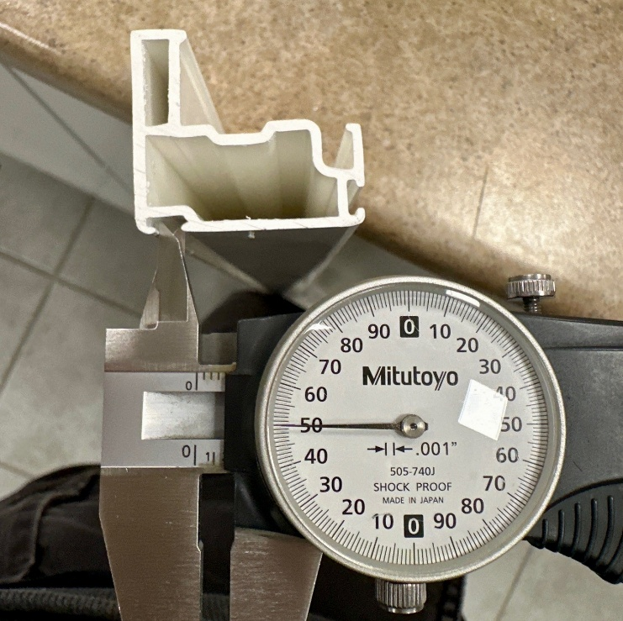 |  | 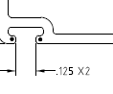

ENSURE WOOL PILE POCKET DIMENSIONS ARE WITHIN SPECIFIED TOLERANCE 0.125 ± 0.010

BY SIGNING BELOW, YOU ACKNOWLEDGE THE PROBLEM ABOVE AND AGREE TO MONITOR THIS ISSUE IN FUTURE PRODUCTION RUNS.
DAY SHIFT |  | AFTERNOON SHIFT |  | NIGHT SHIFT
NAME | SIGNATURE | NAME | SIGNATURE | NAME | SIGNATURE

